|  |  |  |  |
| --- | --- | --- | --- |
| **Internship Prosensia** | | | |
| **CEO** | Mr. Momin Khan | **Company** | Prosensia |
| **Team Lead** | Mr. Mobeen Sarwar | **Internship**  **Field** | C++ |
| **Internship Day** | Day 1 | **Session** | SUMMER 2025 |
| **Name** | Meeran Ahmed Khan | **Reg no.** | S25017 |
| **Content Covered** | Basic Input and Output , Data and Variables | | |

**Day 1 tasks:**

**Task 1: Hello World**

|  |
| --- |
| #include <iostream>  using namespace std;  int main() {  cout << "Hello World";  return 0;  } |

**Task 2: Age Input**

|  |
| --- |
| #include <iostream>  using namespace std;  int main() {  int age;  cout << "Enter your age: ";  cin >> age;  cout << "You entered: " << age;  return 0;  } |

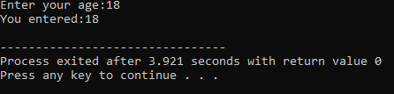

**Task 3: Student Information**

|  |
| --- |
| #include <iostream>  using namespace std;  int main() {  string name;  int age;  float gpa;  cout << "Enter name: ";  cin >> name;  cout << "Enter age: ";  cin >> age;  cout << "Enter GPA: ";  cin >> gpa;  cout << "\nStudent Details:\n";  cout << "Name: " << name << endl;  cout << "Age: " << age << endl;  cout << "GPA: " << gpa;  return 0;  } |

